**Manuals for ‘Manage Job Category’**

**Brief of the ‘Manage job Category’ –** This is the page where we manage job category.

**1. How to manage job category-.**

Steps:

1. Login to the site and go to ‘Career’ tab and click on ‘Manage job category ’.
2. On ‘Manage Job category’ page the listing of job category and ‘Add job category’ button will display.
3. On this page we can edit and delete the existing records.
4. Click on ‘Add job category’ button for add new job category.
5. The added new job category’ will display with career page.

1.

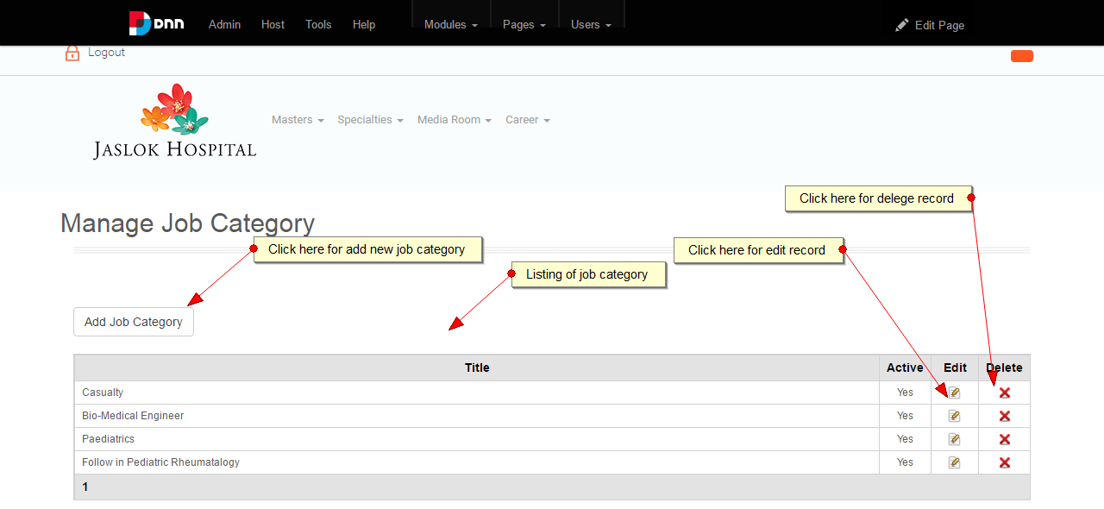

2.

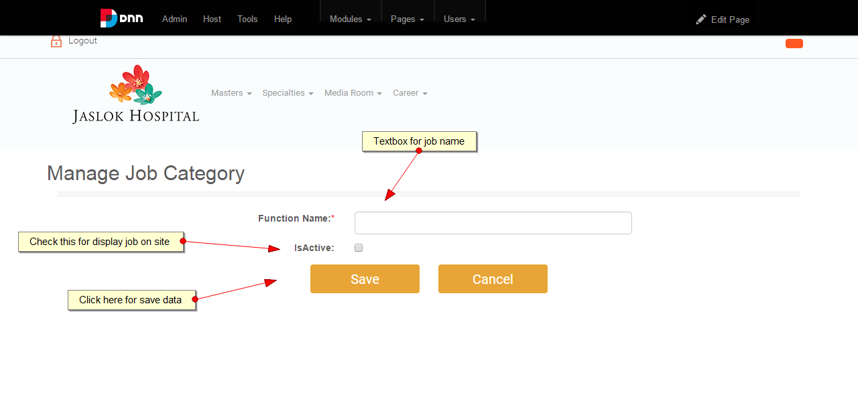

3.

